**GTU Department of Computer Engineering**

**CSE241/501 – Fall 2022**

**Homework #08 Report**

**Muhammet Çağrı Yılmaz**

**1901042694**

**Instructions of Peg Solitaire**

Peg Solitaire is a game that consists of a board with 33 holes arranged in the pattern given in the pictures below. At the start, every hole except the center is filled with a peg. The player then starts jumping pegs. Any peg that is jumped over is removed, just as in checkers. Vertical and horizontal jumps are allowed, but diagonal jumps are forbidden. The goal is to remain only one peg.

Game Photos and Definitions

-When user starts playing the game first, a screen will be come.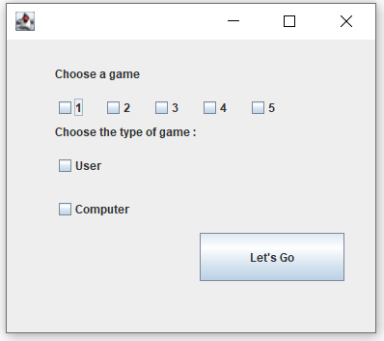

First section, users make a decision which game he(she) wants to play.

Second section, users make a decision who plays the game. In the downwards you can see an example. User cannot go on without any choosing thanks to this code:

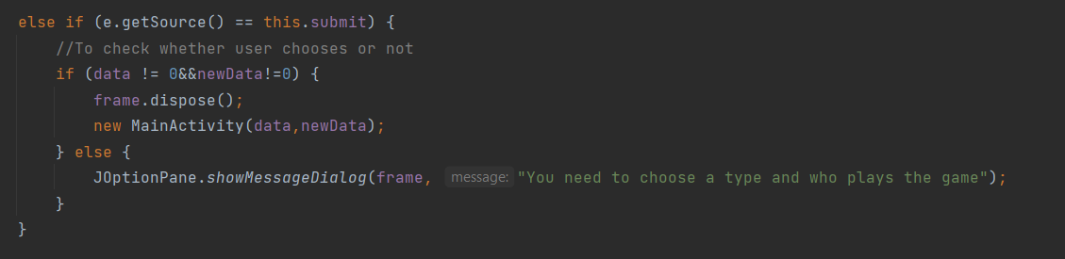

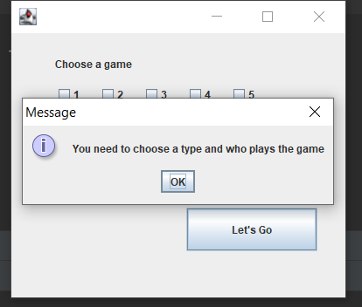

First game and screen look like this:

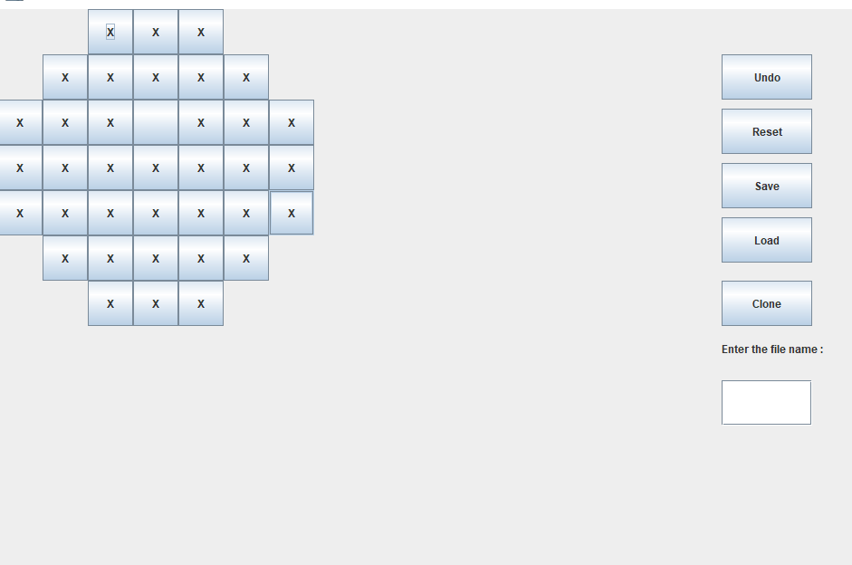

Now we are looking the components of the game (undo,reset,save,load,clone)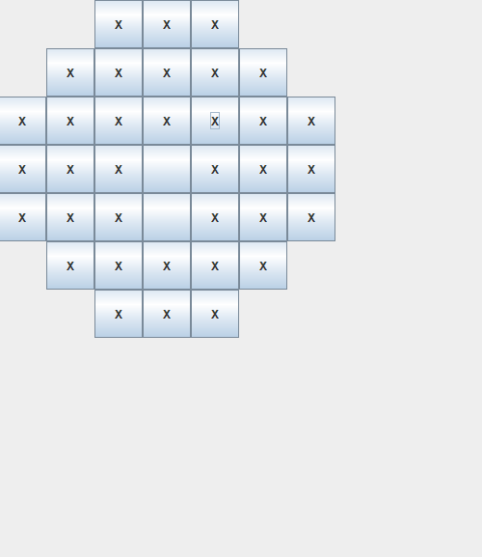

If we click undo button game will turn the old situation.

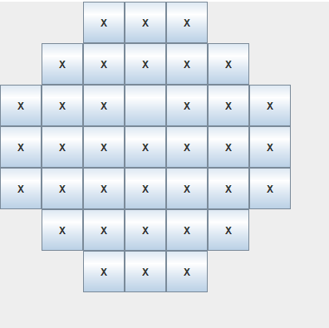

**CLONE:**

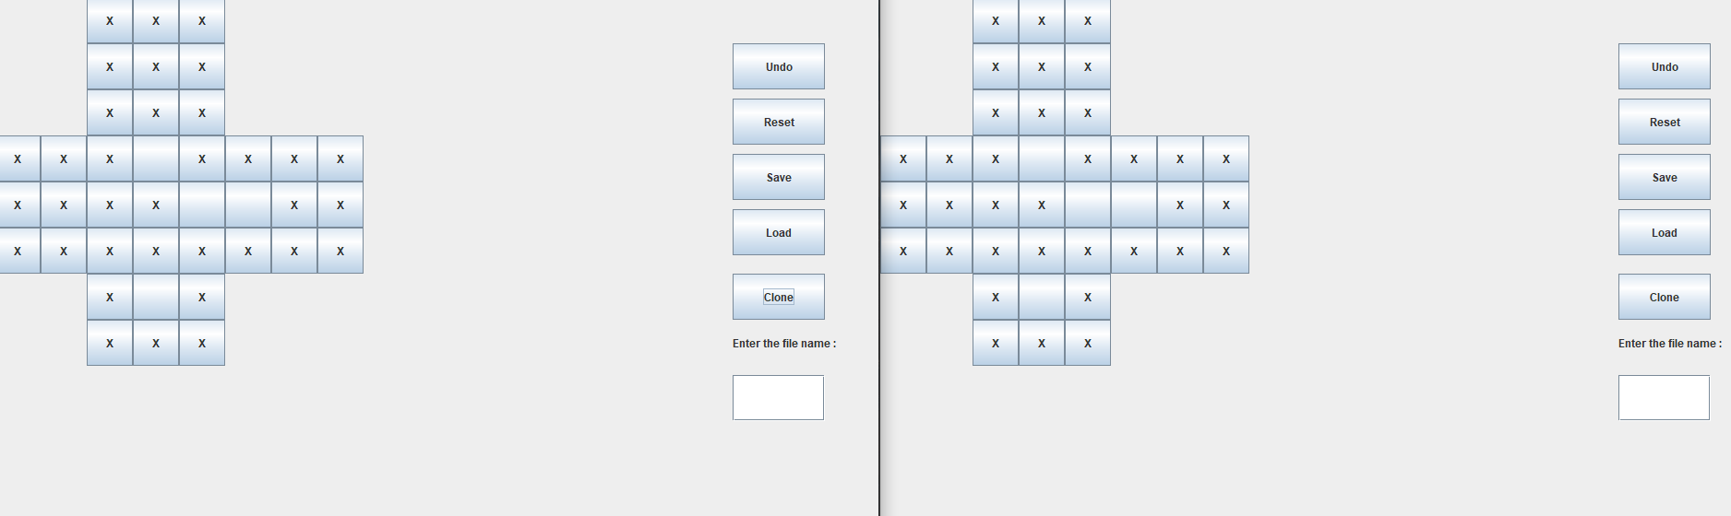

When the game is finished, user will see result.

